RC: RNN + CNN1D

CP: CNN1D + parallel structure

CR: CNN1D + residual block

X: XGBoost

S: SVM

A: ANN

S: Shuffle

N: No shuffle

Tr: Training set

V: Validation set

T: Test set

Files[5]: G07_Freezing_Trial1_trial_1_emg.csv

Files[6]: G08_FoG_1_trial_1_emg.csv

Files[7]: G08_FoG_2_trial_1_emg.csv

Files[30]: G09_Walking_trial_2_emg.csv

Files[31]: G09_Walking_trial_4_emg.csv

Files[32]: G09_Walking_trial_6_emg.csv

Files[33]: G11_Walking_trial_2_emg.csv

Files[34]: G11_Walking_trial_4_emg.csv

Files[35]: P231_M050_A_Walking_trial_2_emg.csv

e.g. RC_S_TR: Training set of RNN + CNN1D model with shuffle

multi_5: multiclassification(1:2:6) drop files[5,30,31,32,33,34,35] out.

binary_6: binary classification(0:others) drop files[6,30,31,32,33,34,35] out.

2-6_7: binary classification(2:6) drop files[7,30,31,32,33,34,35] out.

## Results of test set

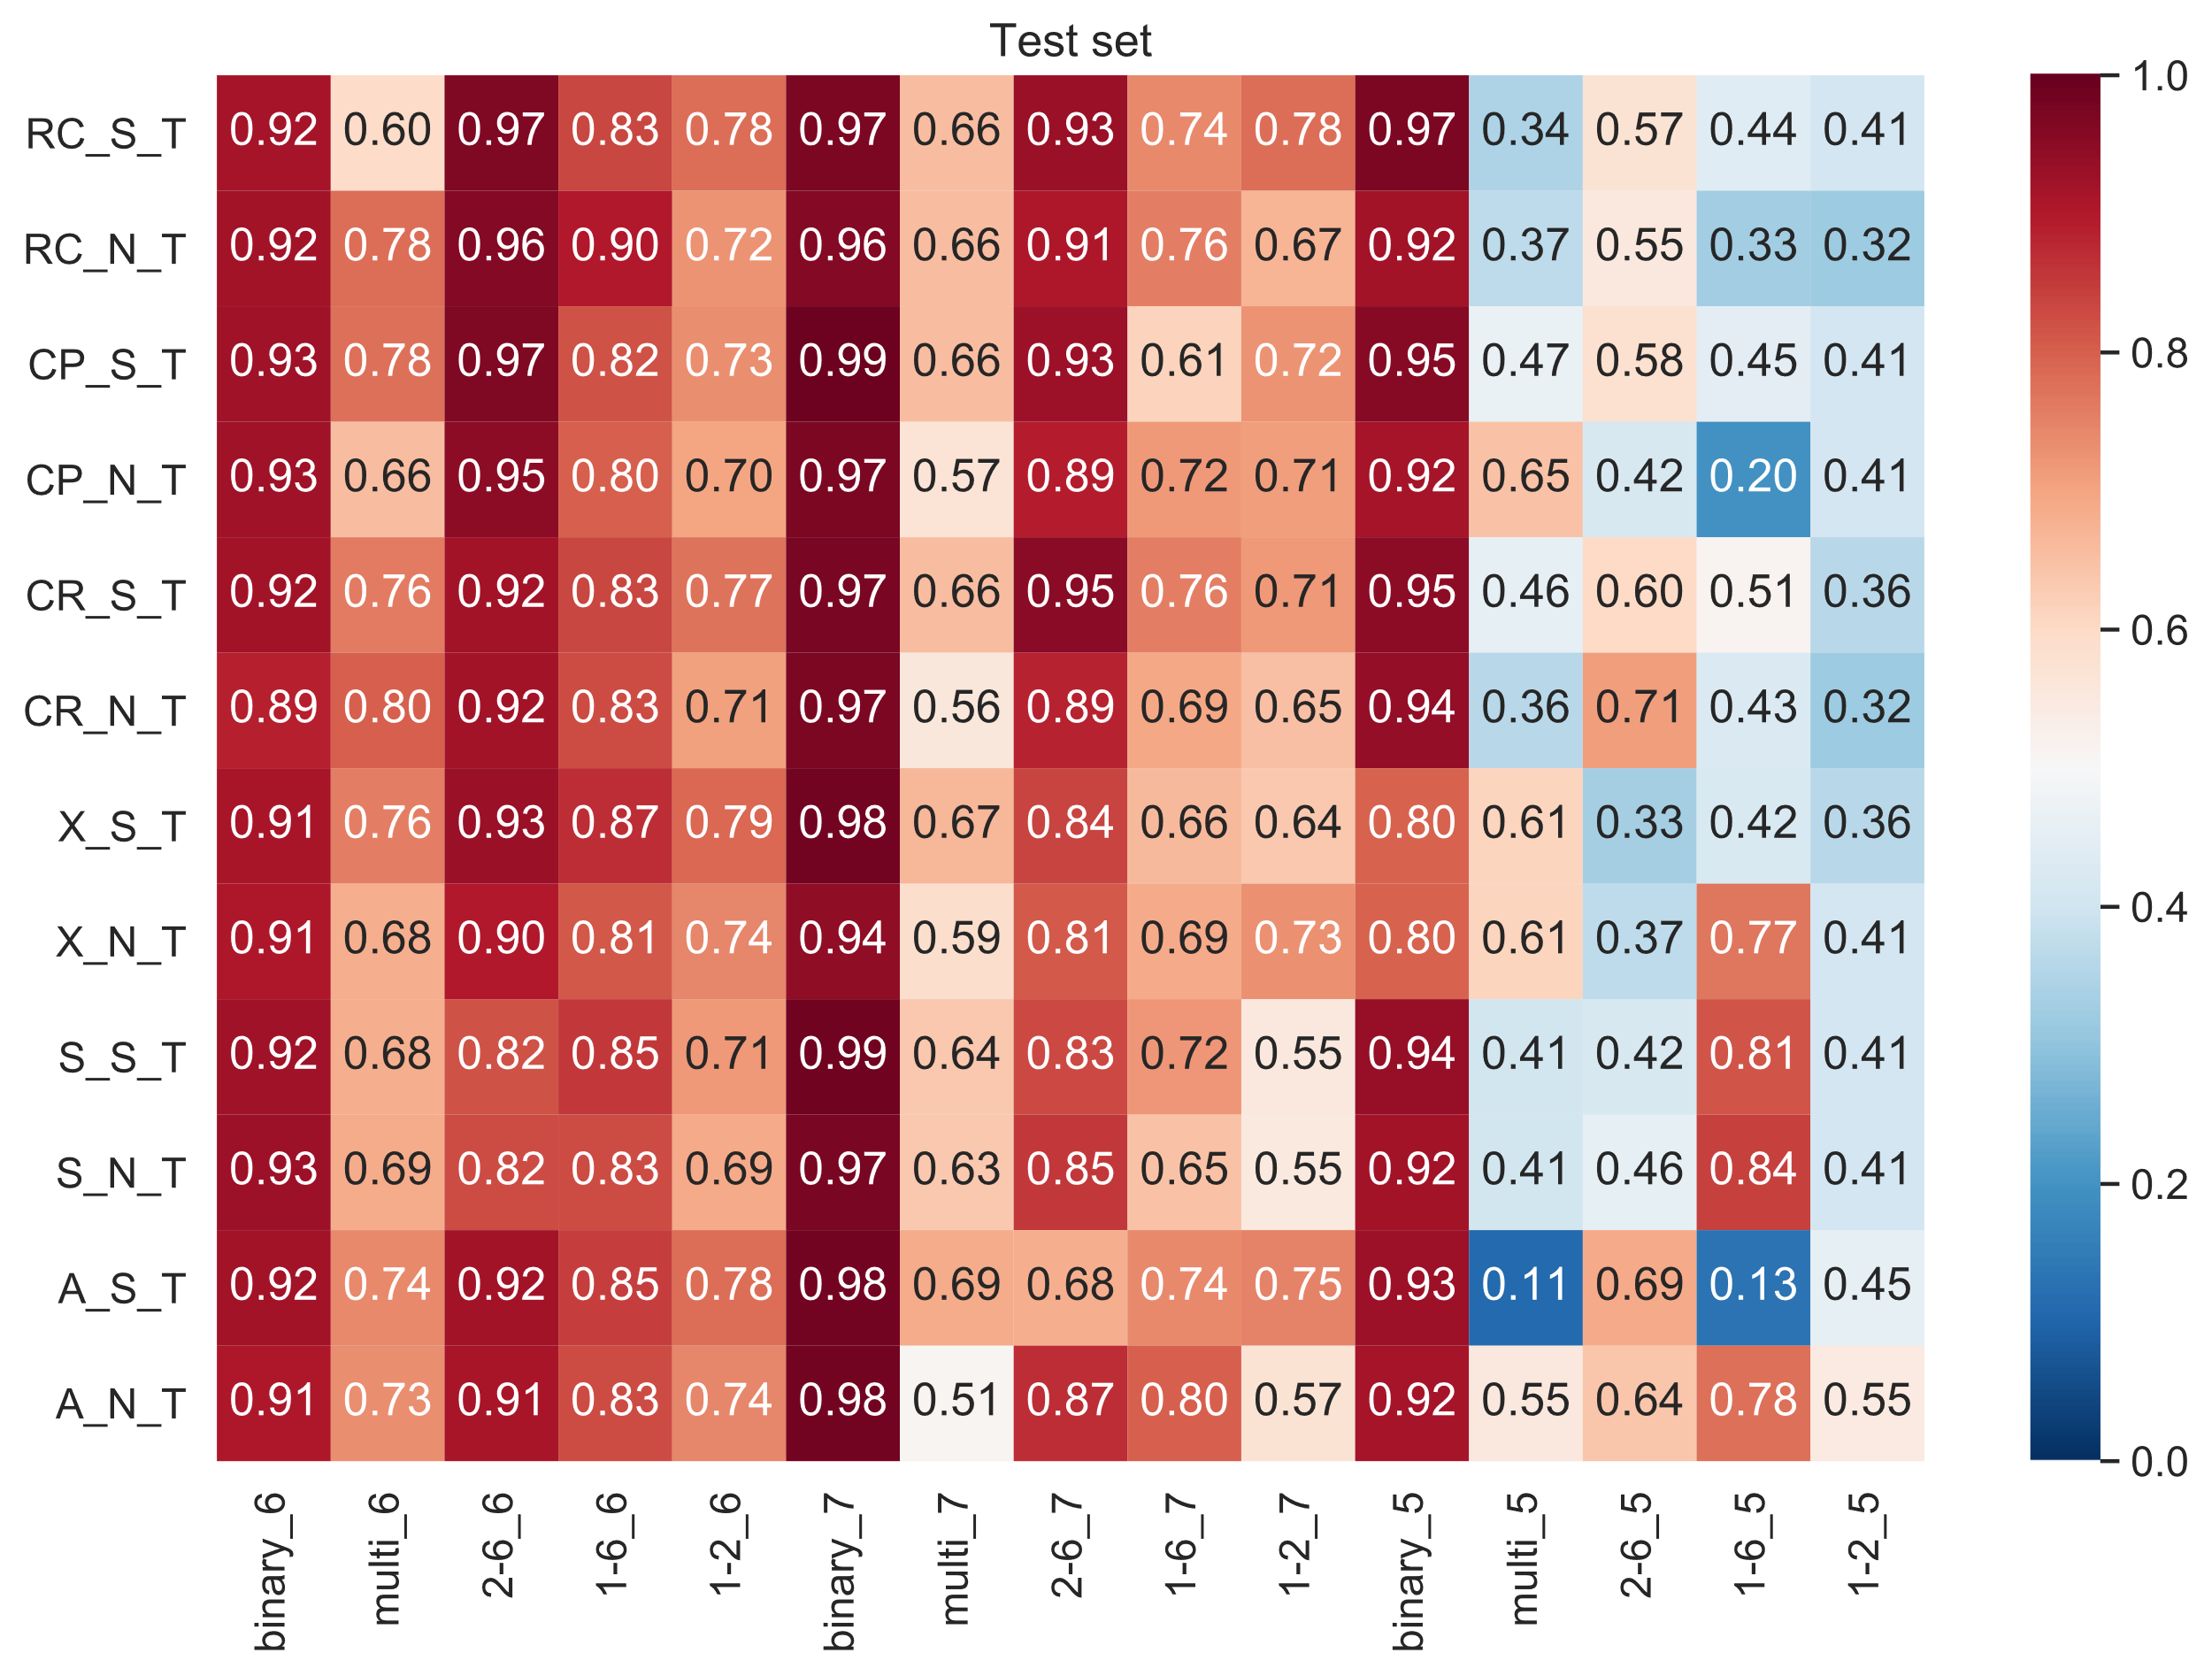

## Results of validation set

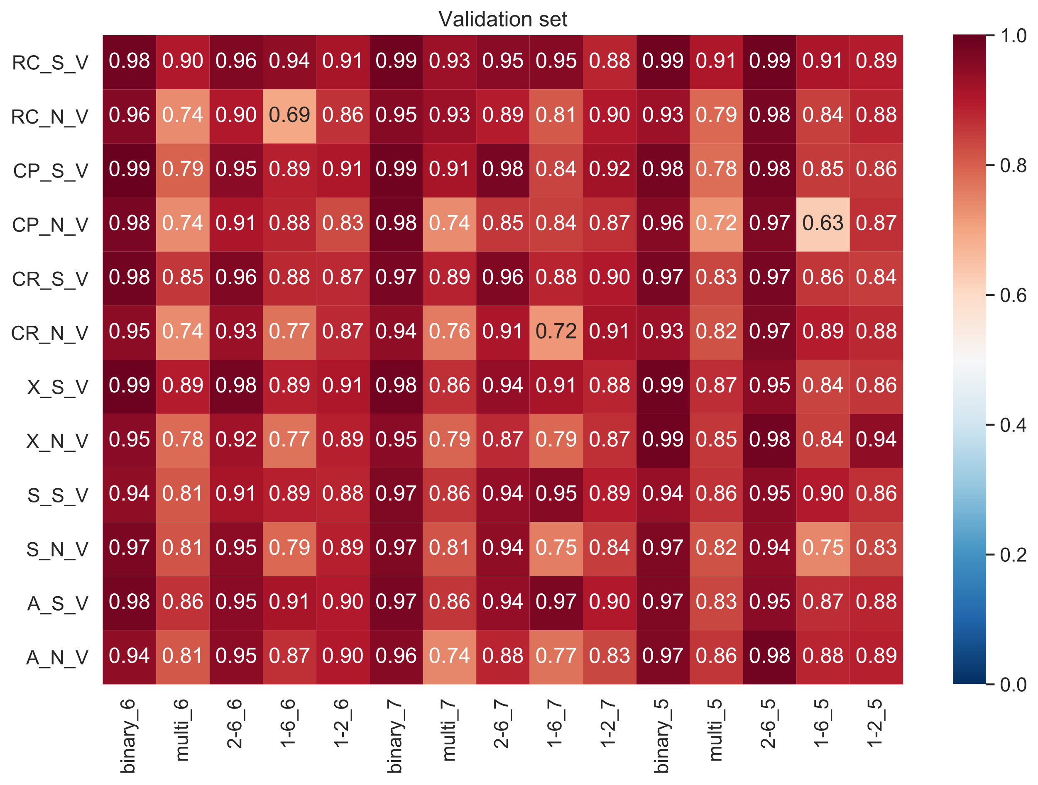

## **Results of shuffled data**

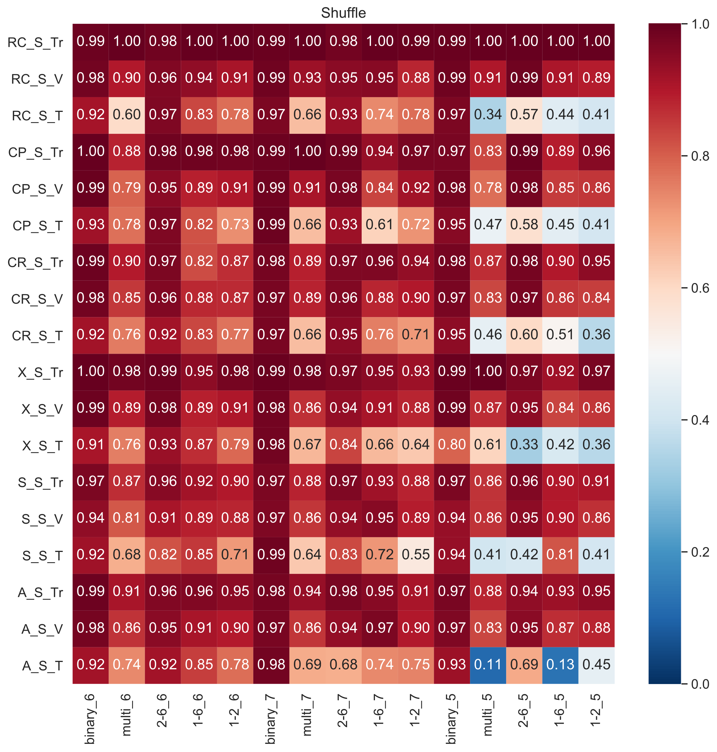

## Results of unshuffled data

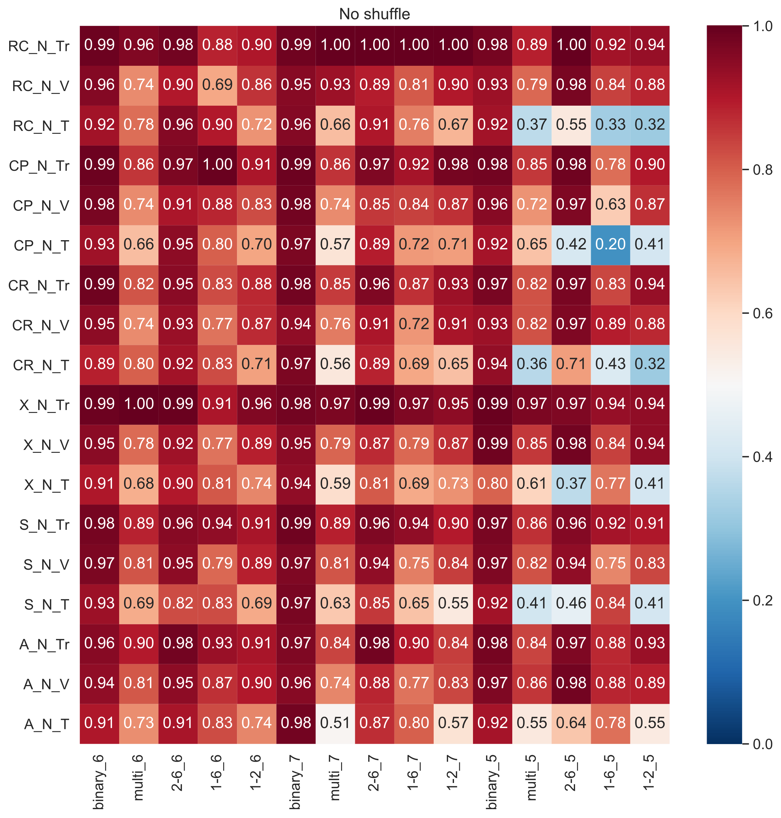

## Results of all

